Creating/Completing a Remittance Request

purpose
These procedures document the process for creating or completing a remittance request. There are numerous permutations that occur when filling out a request. This document will attempt to document these permutations and the correct way of dealing with each of them.

Scope
Remittance requests are, generally speaking, filled out by the contractor (entity) to report on allocations that were withheld from the member across a specific time period (monthly, weekly). These requests are filled out and verified, then finalized and payment is received and then allocated.

PRIORITY
As Needed (in keeping with the reporting requirements of the Local managing the remittance). This is almost always weekly or monthly.

frequency
Remittance request frequency will vary from org to org. Typically, each organization will collect remittance from their respective contractors (entities) on a weekly or at most monthly basis.

RESPONSIBILITY
Overseen by the Local funds and plans office, but the contractors also participate to submit the hours/wages.

PROCEDURE

Finding an Existing Remittance Request

Using the Index Grid to Find an Existing Remittance Request

Within the Index Grid on the left of the screen, click on ‘Remittance’.
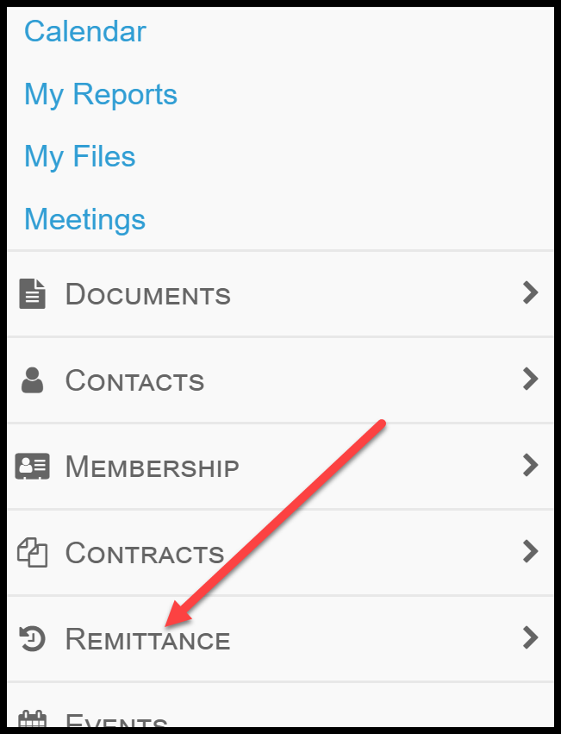

Once the table opens with all available remittance requests, click on the ‘Any Company’ header link and input the desired company in the search bar.
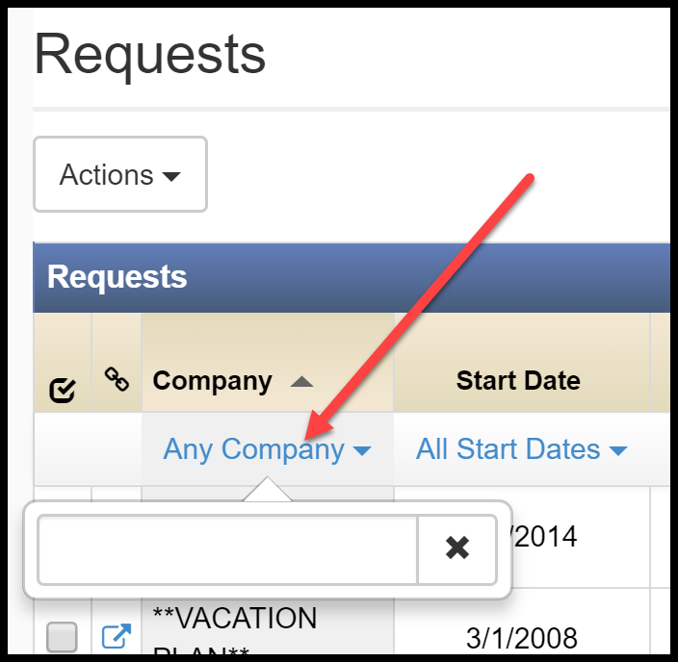

Click on the ‘Start Date’ header to sort the request by the most recent start date. Once the desired request has been identified, click on that row to open that specific request.

Using the Search Bar to Find an Existing Remittance Request

Enter the desired contractor in the search bar at the top-right of the screen and then click the magnifying glass icon to initiate the search.
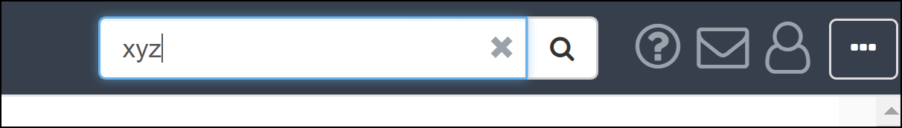

After clicking on the Contact Profile icon, click ‘Remittance’ and then ‘Requests’.
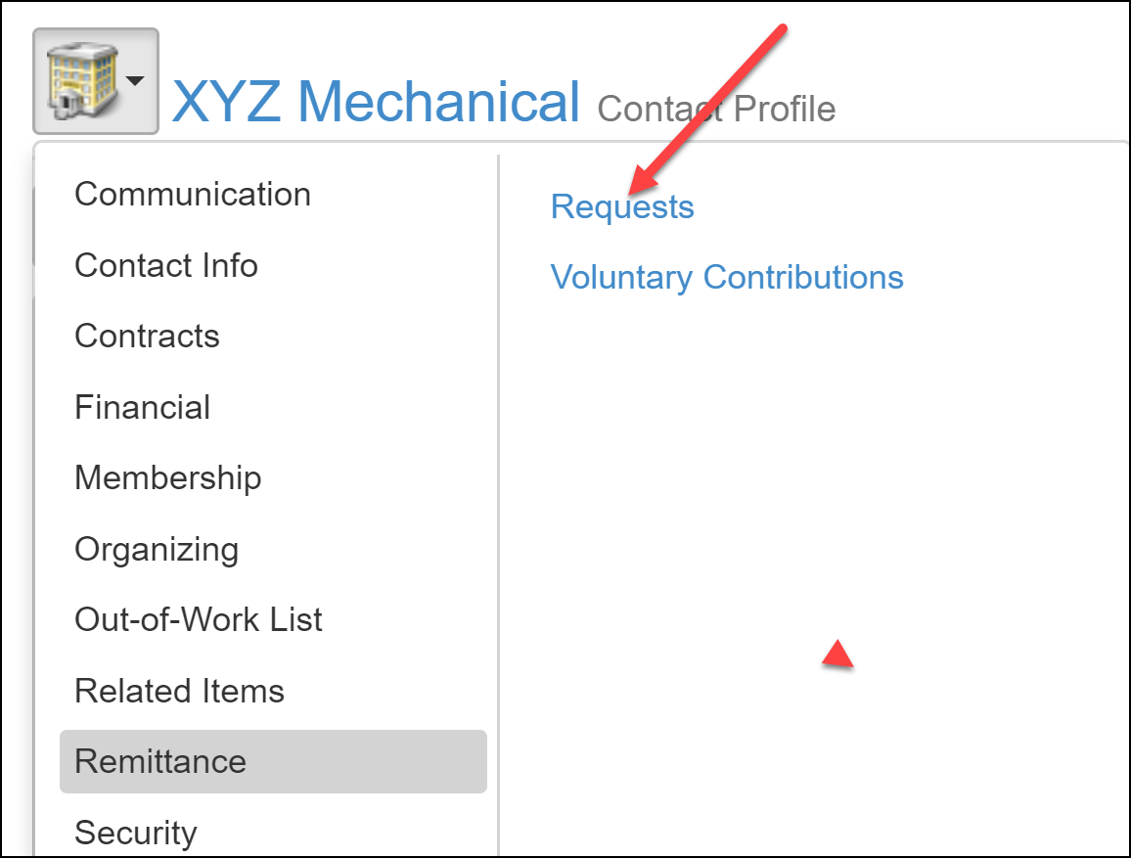

With the listing of available remittance requests open for that particular contractor, click on the ‘Start Date’ header to sort the request by the most recent start date. Once the desired request has been identified, click on that row to open that specific request.

Creating a New Remittance Request

Creating a New Remittance Request Using the Index Grid

From the Index Grid, click ‘Remittance’.

With the table of available requests open, click the ‘Action’ button near the top-left and then ‘Create Request’.
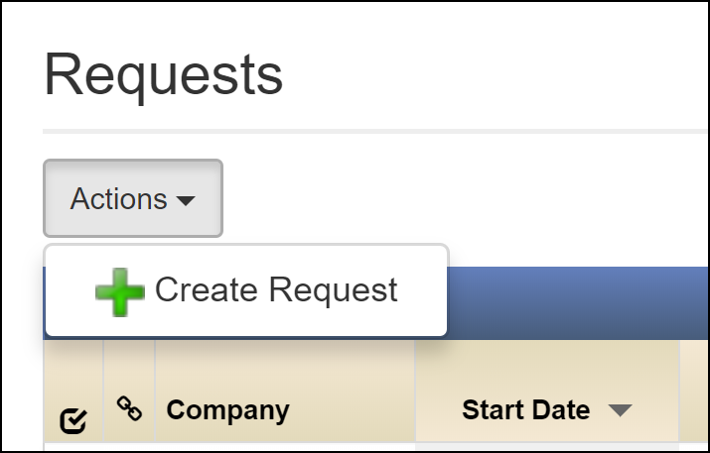

In the Request Creation screen, input the desired contractor, schedule (biweekly/weekly/monthly) and From/To dates for the new remittance request. Effective Rate date and Request Type are not required. Once done, click ‘Save Request’.
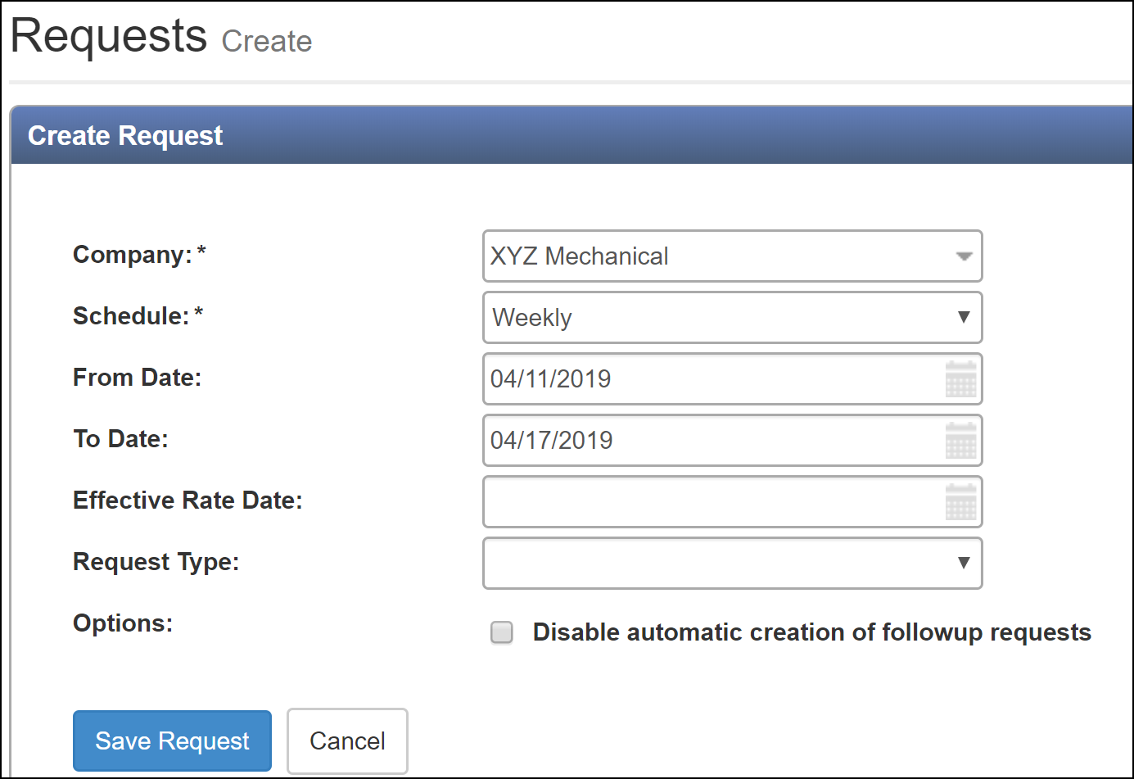

Creating a New Remittance Request Using the Search Bar

Input the desired contractor in the Search Bar at the top of the screen and use the magnifying glass to initiate the search.
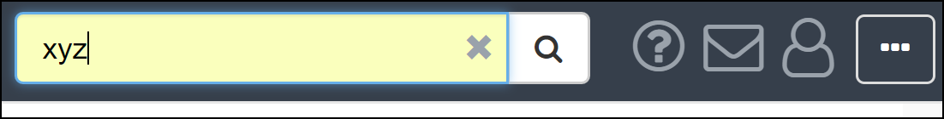

Click on the Contact Profile button and then click ‘Remittance’ and then ‘Requests’.
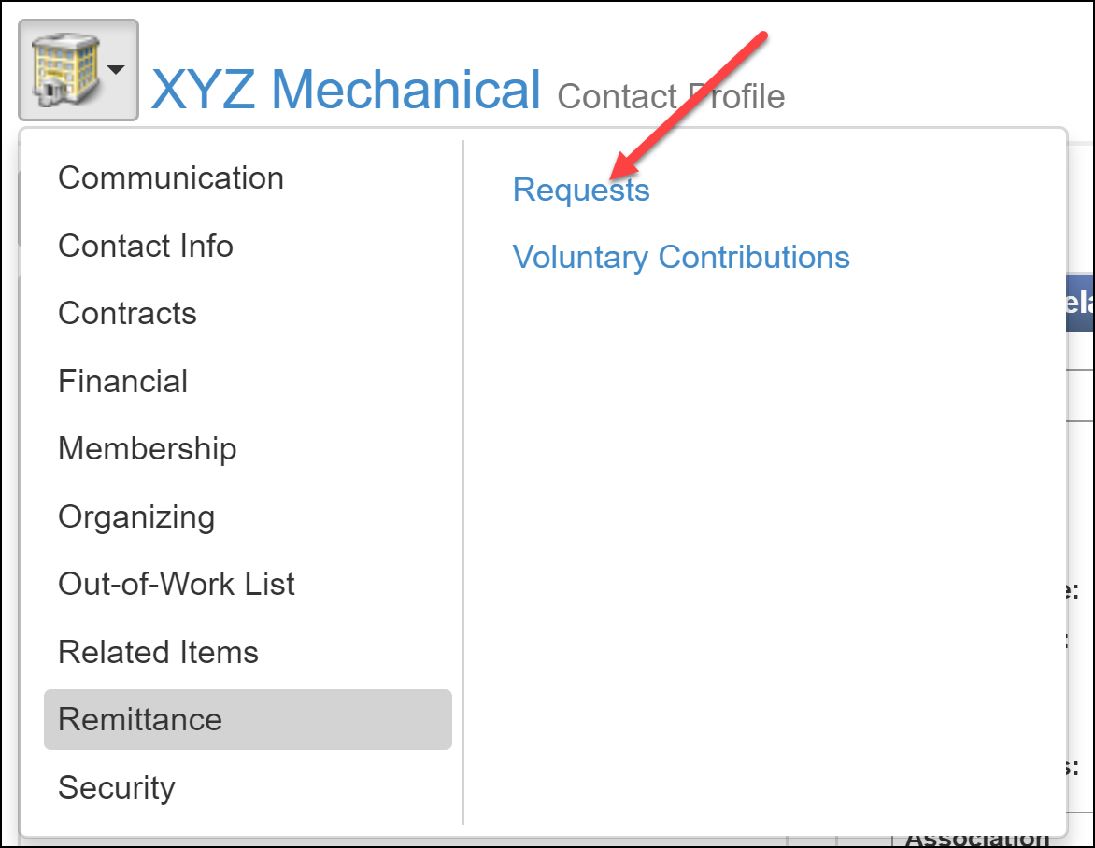

Click on the ‘Actions’ button and the click ‘Create Request’.
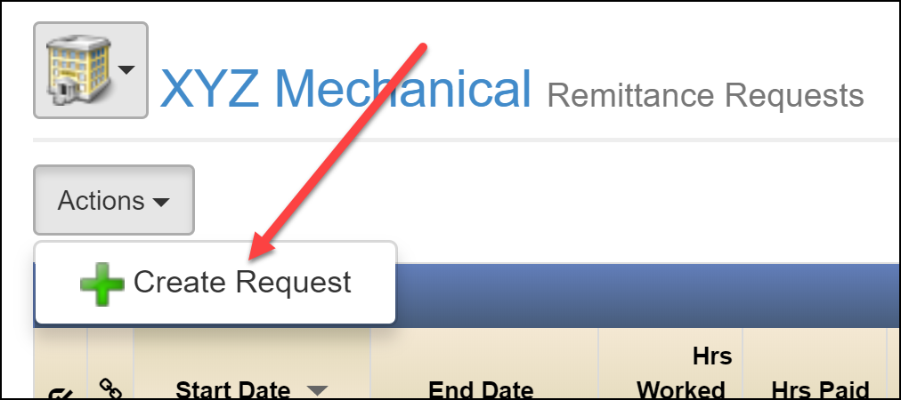

Note that in the Request Creation screen, the contractor is pre-loaded. Input the desired schedule (biweekly/weekly/monthly) and From/To dates for the new remittance request. Effective Rate date and Request Type are not required. Once done, click ‘Save Request’.
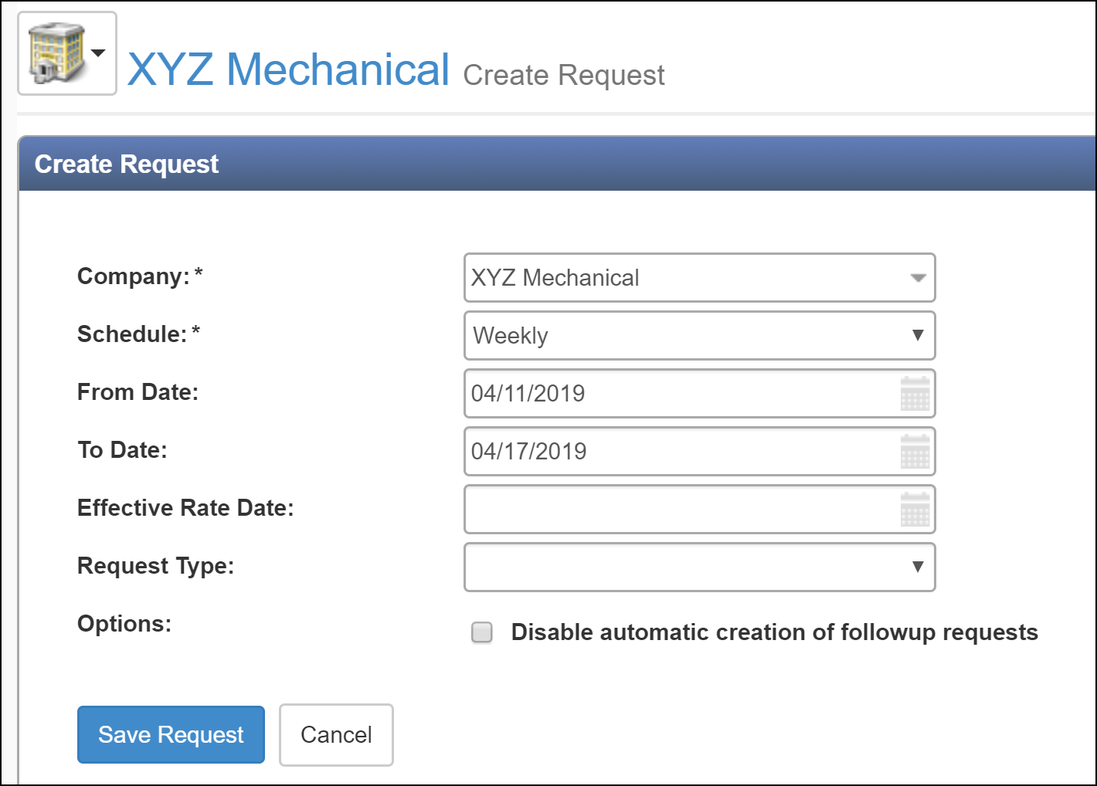

Adding a Wage Package

Adding a Wage Package by Package Mode

With the desired remittance request that was just created/found open, click the ‘Group: By Package’ button.

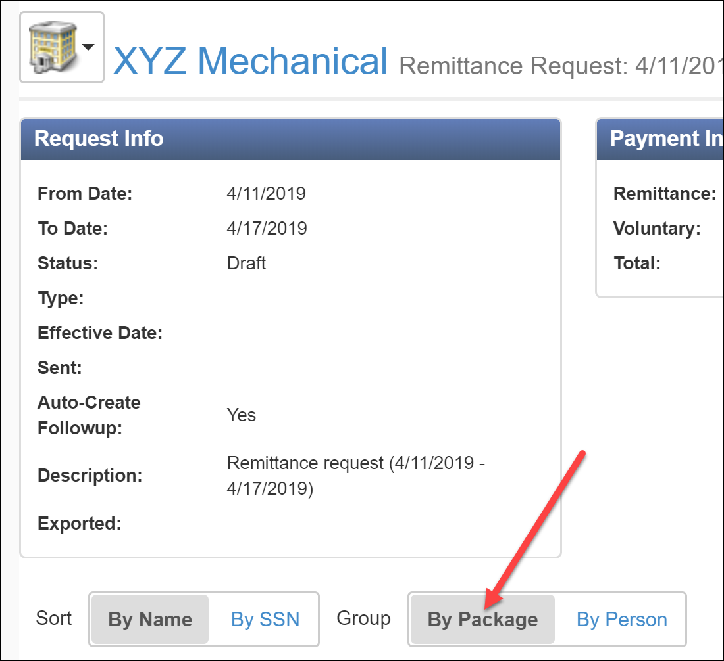

Click the ‘Actions’ button in the top-right of the screen and then click ‘Add Wage Package’.
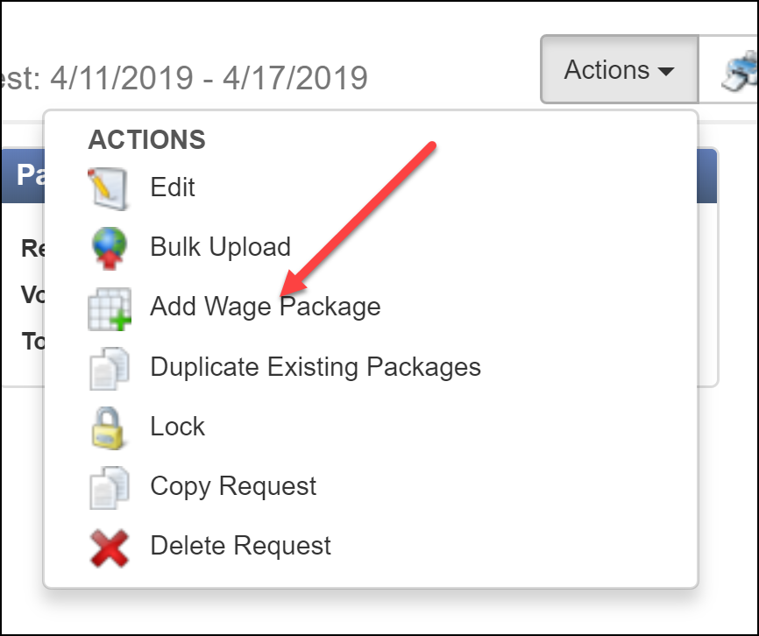

Within the ‘Add Wage Package’ screen, input the desired wage package and date range. Note that Contract Job and Effective Rate Date are optional fields. Click ‘Add’ when complete.
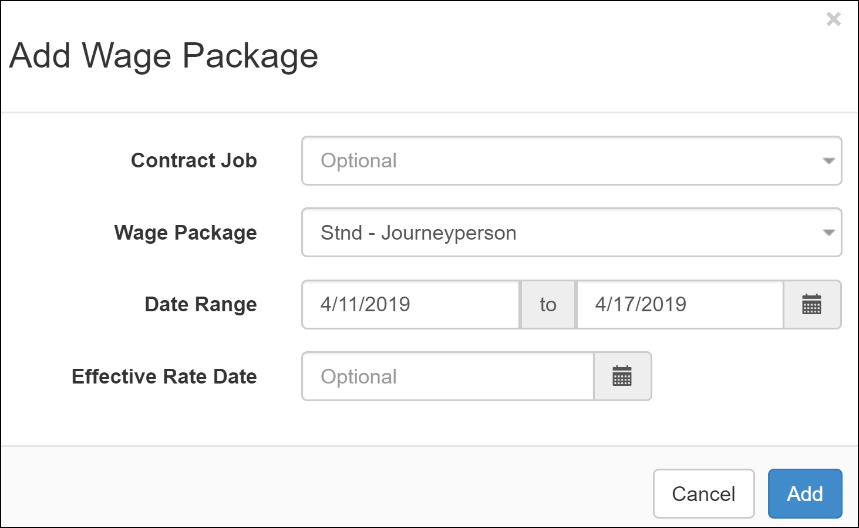

Expand the wage package to enable the ability to search for members to add to that wage package.
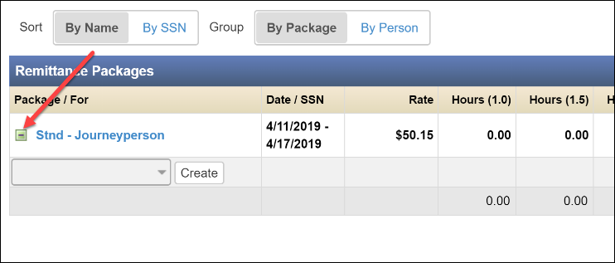

Use the search bar to input members’ names to add them to the package.

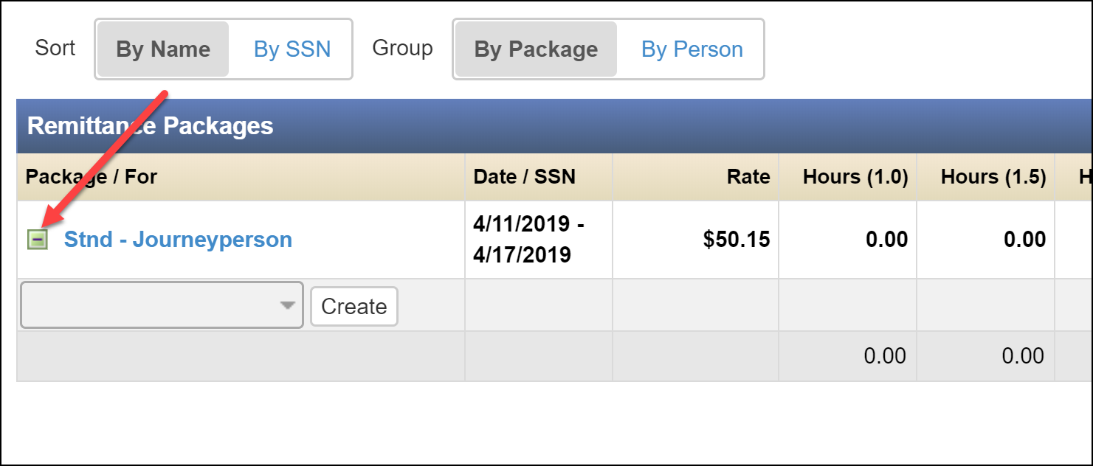

Add all appropriate members as well as their hours worked, shift, and/or total wages for each member included in the wage package. Shift can be adjusted from ‘Regular’, ‘Shift 1 (1.10)’ and ‘Shift 2 (1.15)’.
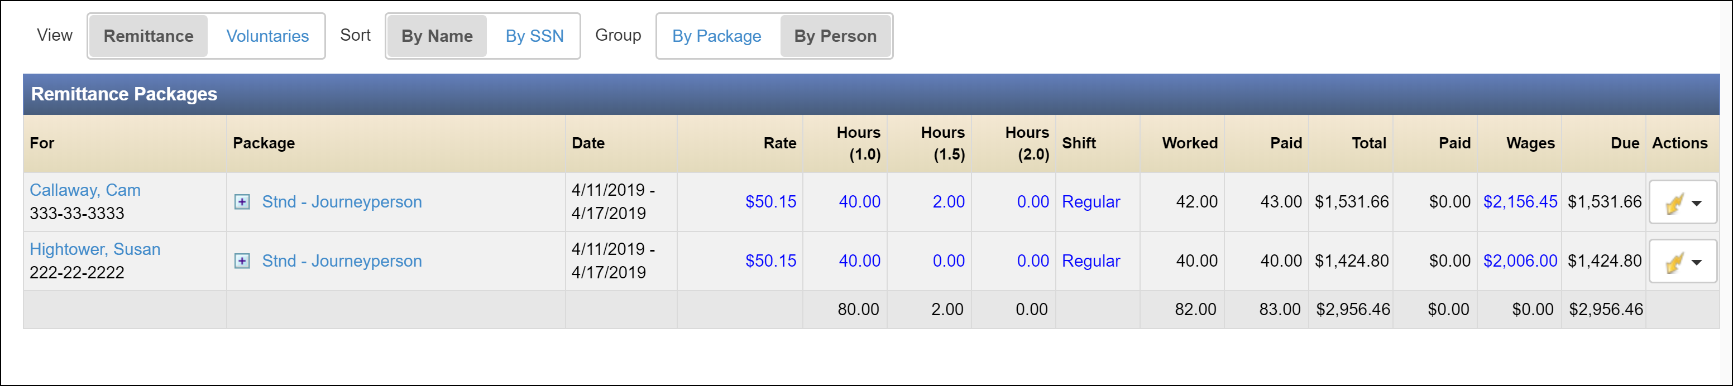

Note that any blue fields are editable. Rate, Hours (1.0), Hours(1.5), Hours (2.0), Shift and Wages can all be changed as needed. Also be aware that changes to one field will affect the values given in others. For example, increasing the value in the Wages field will cause the value in the Rate field to increase accordingly and increasing the Rate, Hours and/or Shift will increase the value shown in the Wages field.

Go back into Actions > Add Wage Package and create another package for any additional wages.
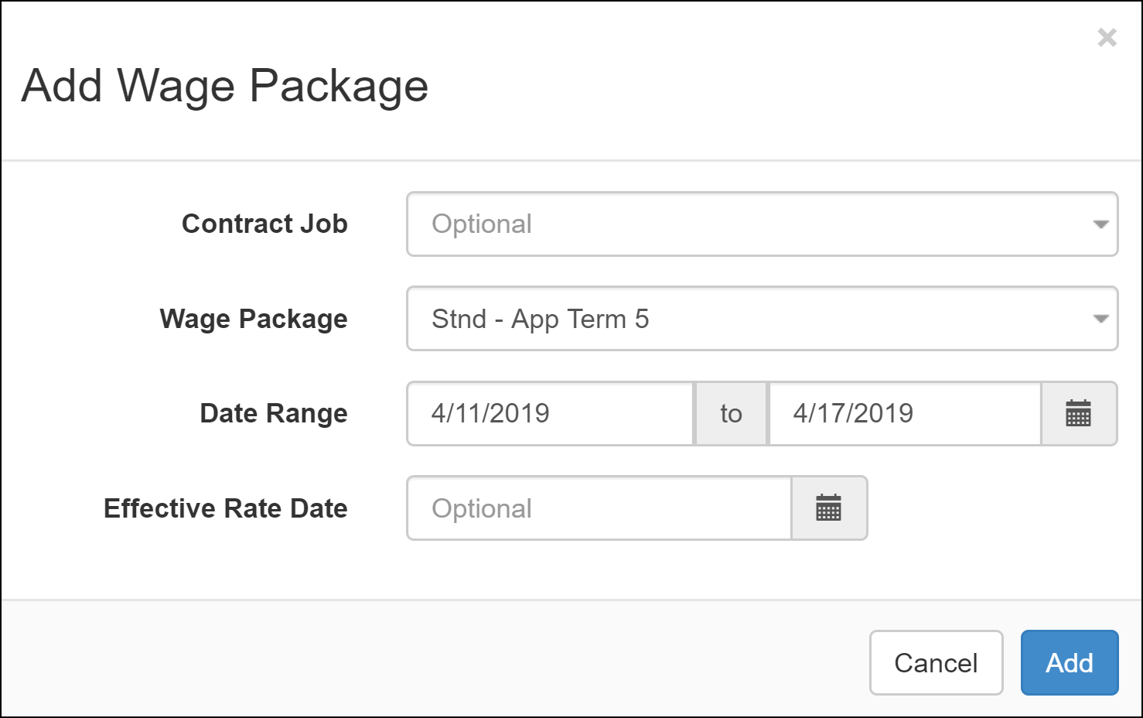

Use the search bar again to find employees that you’d like to add to that wage package. Once found, input their hours for the recorded time frame.
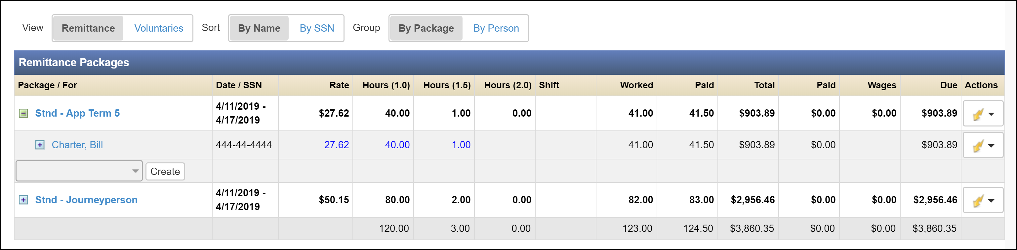

Adding a Wage Package by Person Mode

With the desired remittance request that was just created/found open, click the ‘Group: By Person’ button.
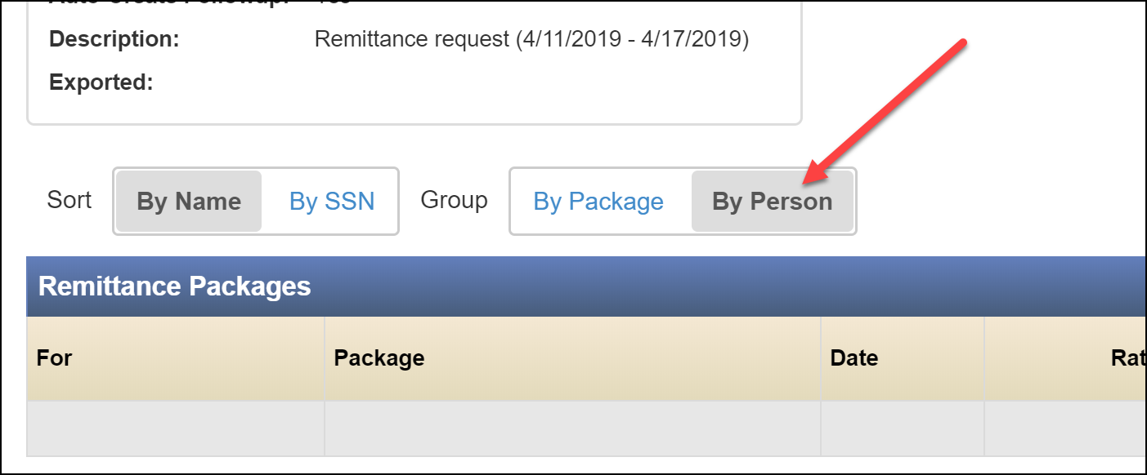

Click the ‘Actions’ button in the top-right and then click ‘Add Person/Package’.
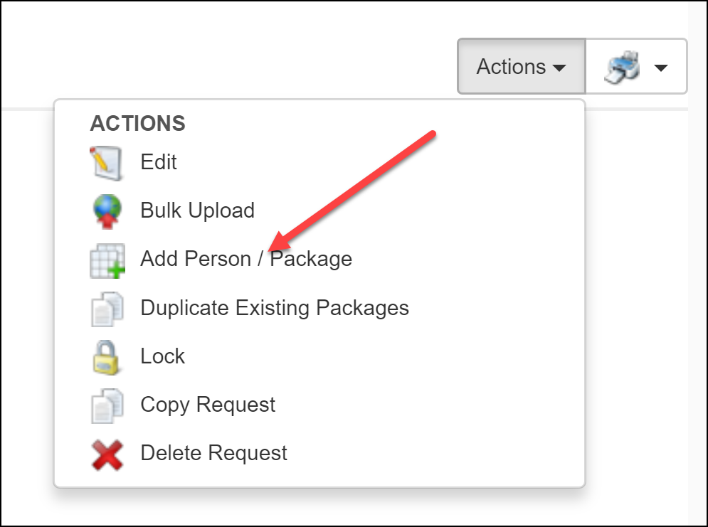

Use the search bar under the ‘Person’ line in the Add Wage Package screen to find the desired employee. Once found, select the appropriate wage package and click ‘Add’. Repeat steps 6.3.2.2 and 6.3.2.3 for all employees who need added to the package.
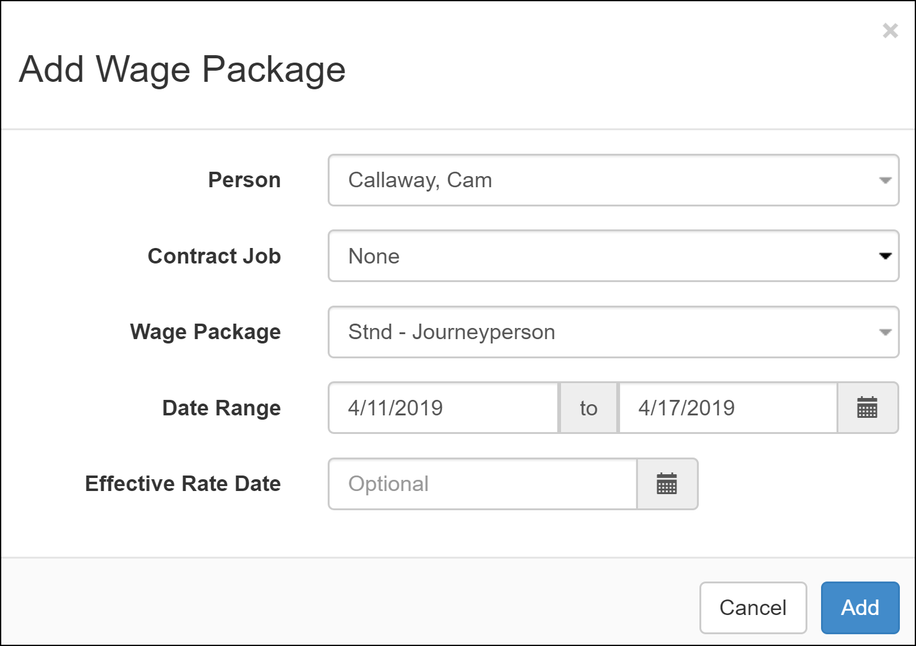
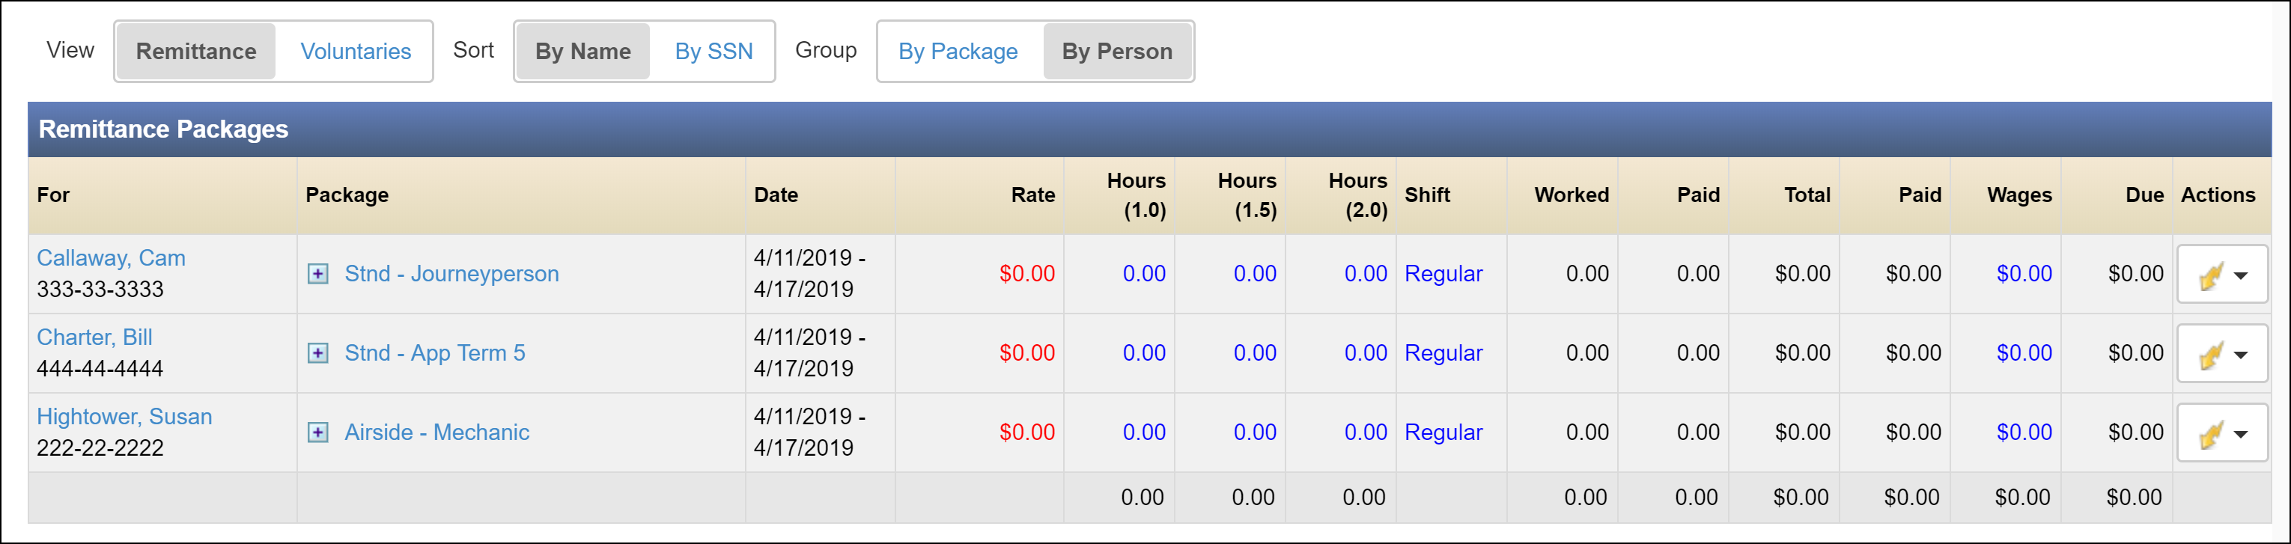

Add all appropriate members as well as their Hours, Shift, and/or total Wages for each member included in the wage package. Shift can be adjusted from ‘Regular’, ‘Shift 1 (1.10)’ and ‘Shift 2 (1.15)’.

Note that any blue fields are editable. Rate, Hours (1.0), Hours(1.5), Hours (2.0), Shift and Wages can all be changed as needed. Also be aware that changes to one field will affect the values given in others. For example, increasing the value in the Wages field will cause the value in the Rate field to increase accordingly and increasing the Rate, Hours and/or Shift will increase the value shown in the Wages field.

Note that it is possible to add multiple packages to the same employee. See the example below. This is accomplished by using 6.3.2.2 and 6.3.2.3 to add the employee to one package (i.e. ‘Stnd – App Term 5’) and then using the same steps again to add them to another package (i.e. ‘School – Apprentice 5’).
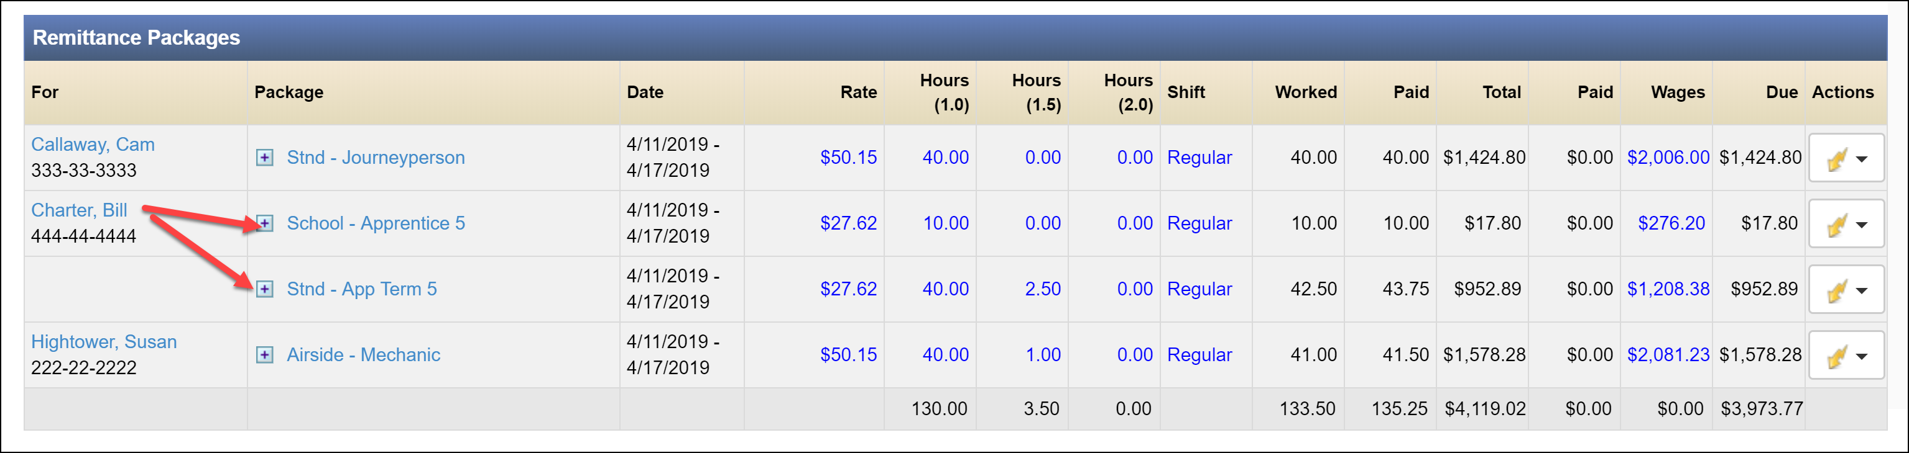

Be aware that the focus/perspective of the Remittance Package can be shifted from the wage packages to the people in the packages by using the Group button.

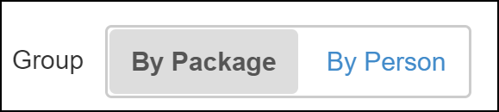

By Package:

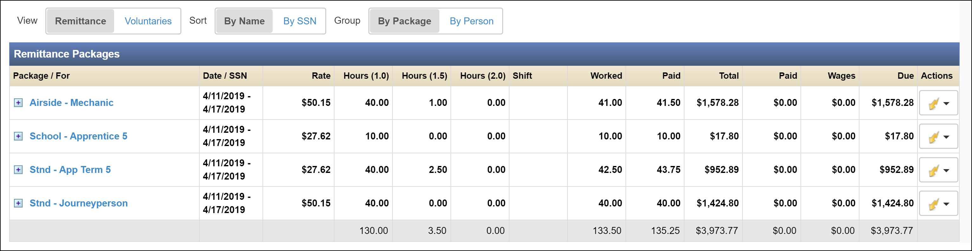

By Person:

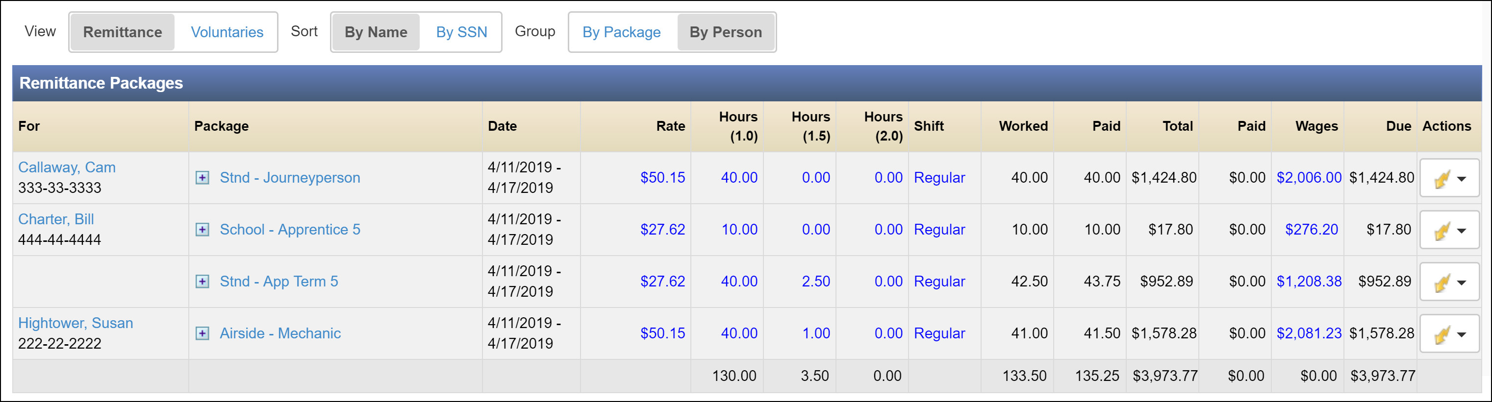

Also note that you can expand the wage package in either case to see the breakout for each wage package by clicking on the expansion button next to each package.
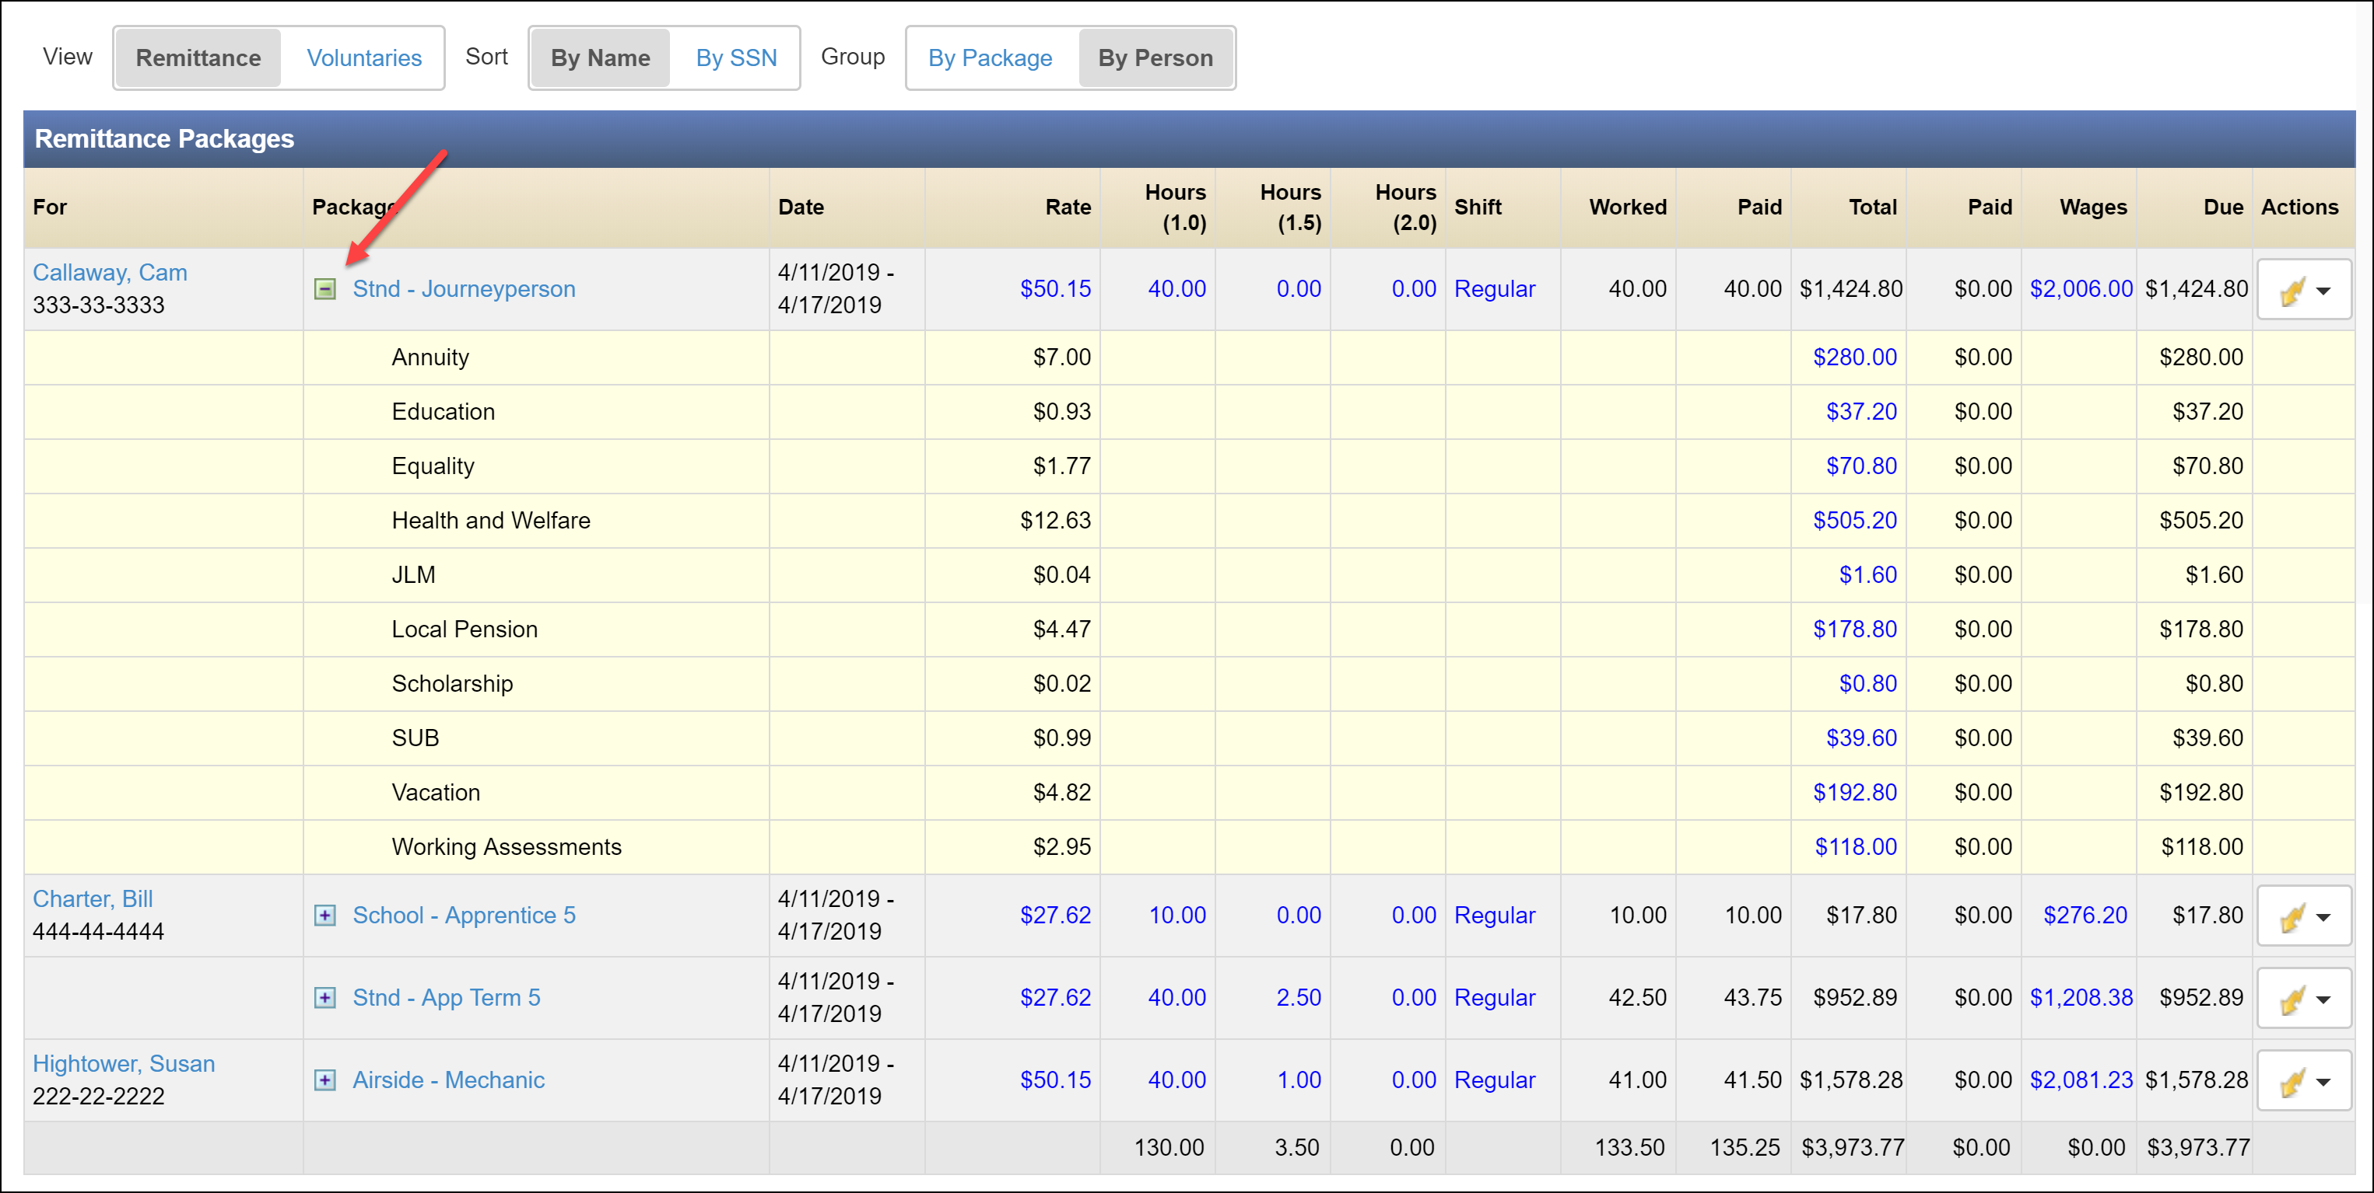

Adding a Contract Job to a Wage Package

From the ‘By Package’ perspective, add a new wage package as was done in step 6.3.1.3. In this instance, select the appropriate Contract Job from the drop-down list. Once selected, choose the appropriate wage package from those available in the drop-down list. Click ‘Add’.
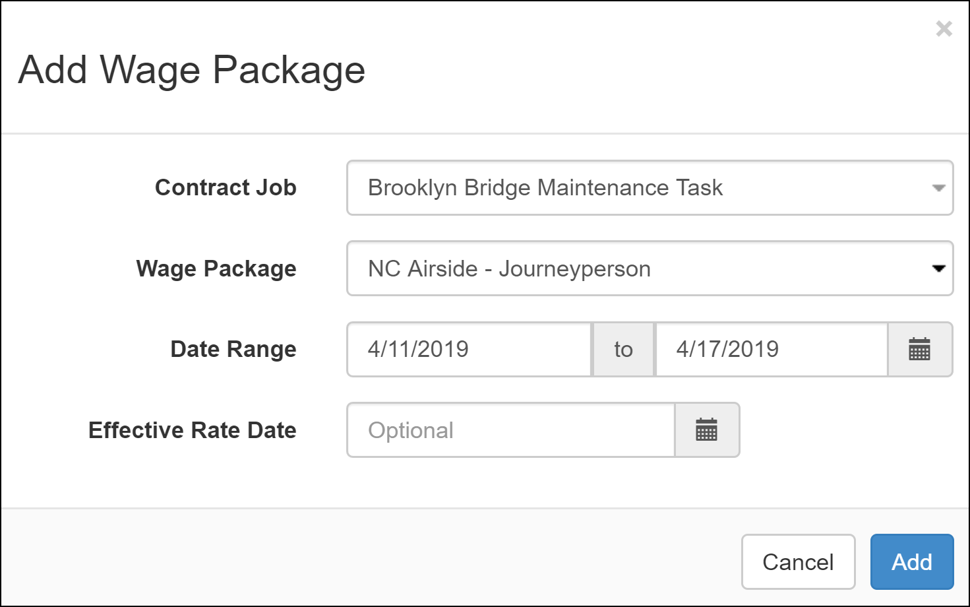

From the ‘By Person’ perspective, add a new wage package as was done in step 6.3.2.3. This time, after finding the correct employee in the ‘Person’ search bar, find the appropriate contract job in the ‘Contract Job’ drop-down. The select the appropriate wage package and then click ‘Add’.
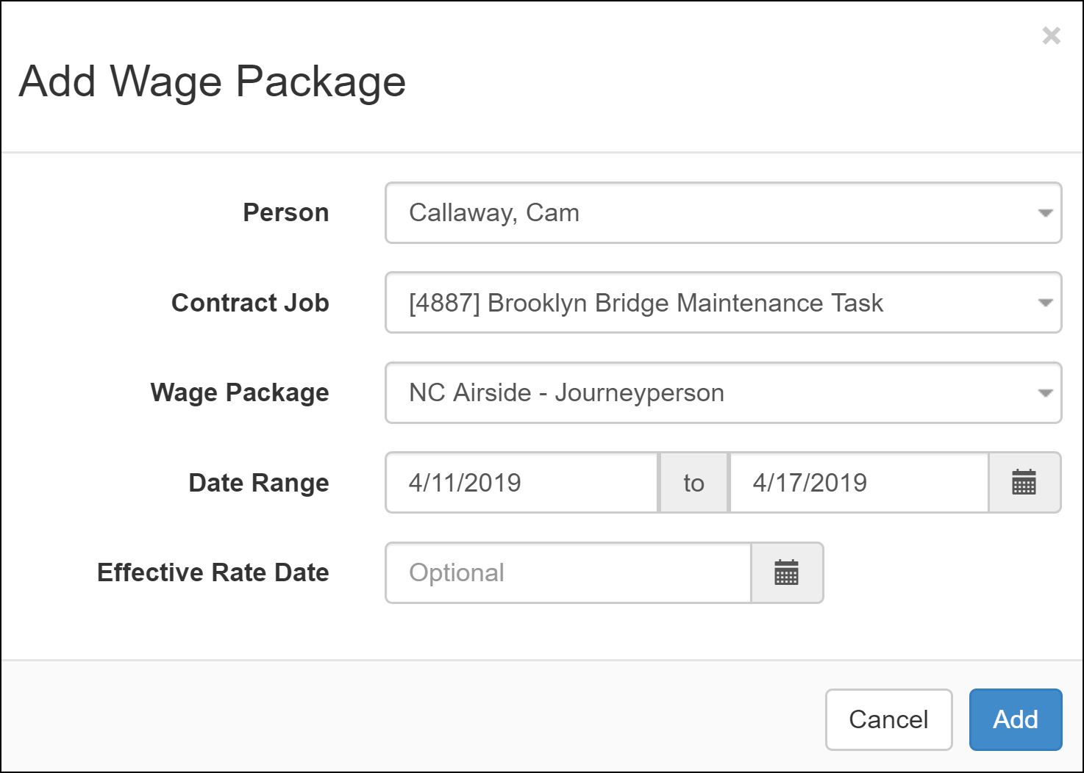

Note that a person is assigned to a Contract Job the same that they’re added to any other wage package from the ‘By Project’ perspective. Hours are also updated the same way.

By Person:

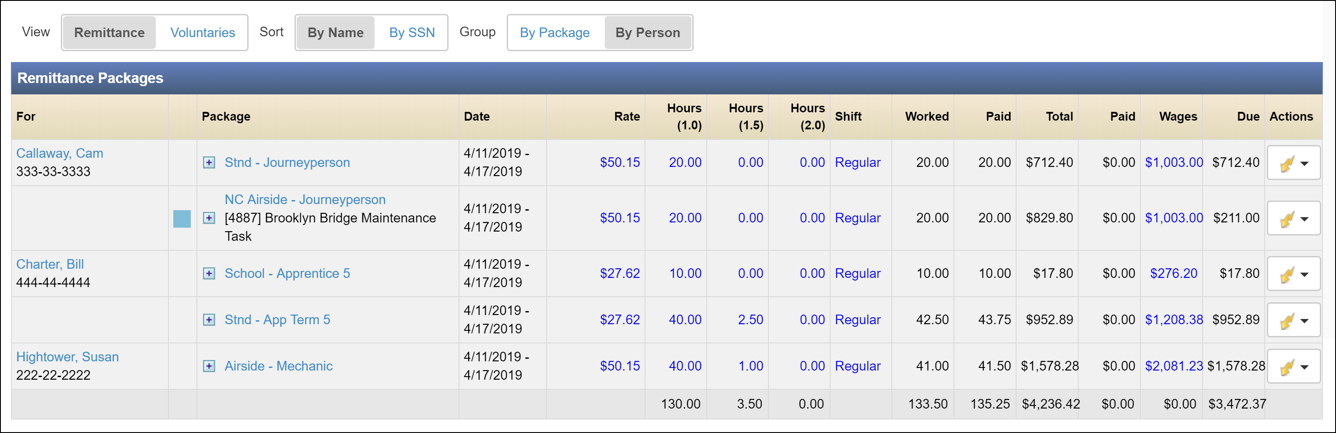

By Package:

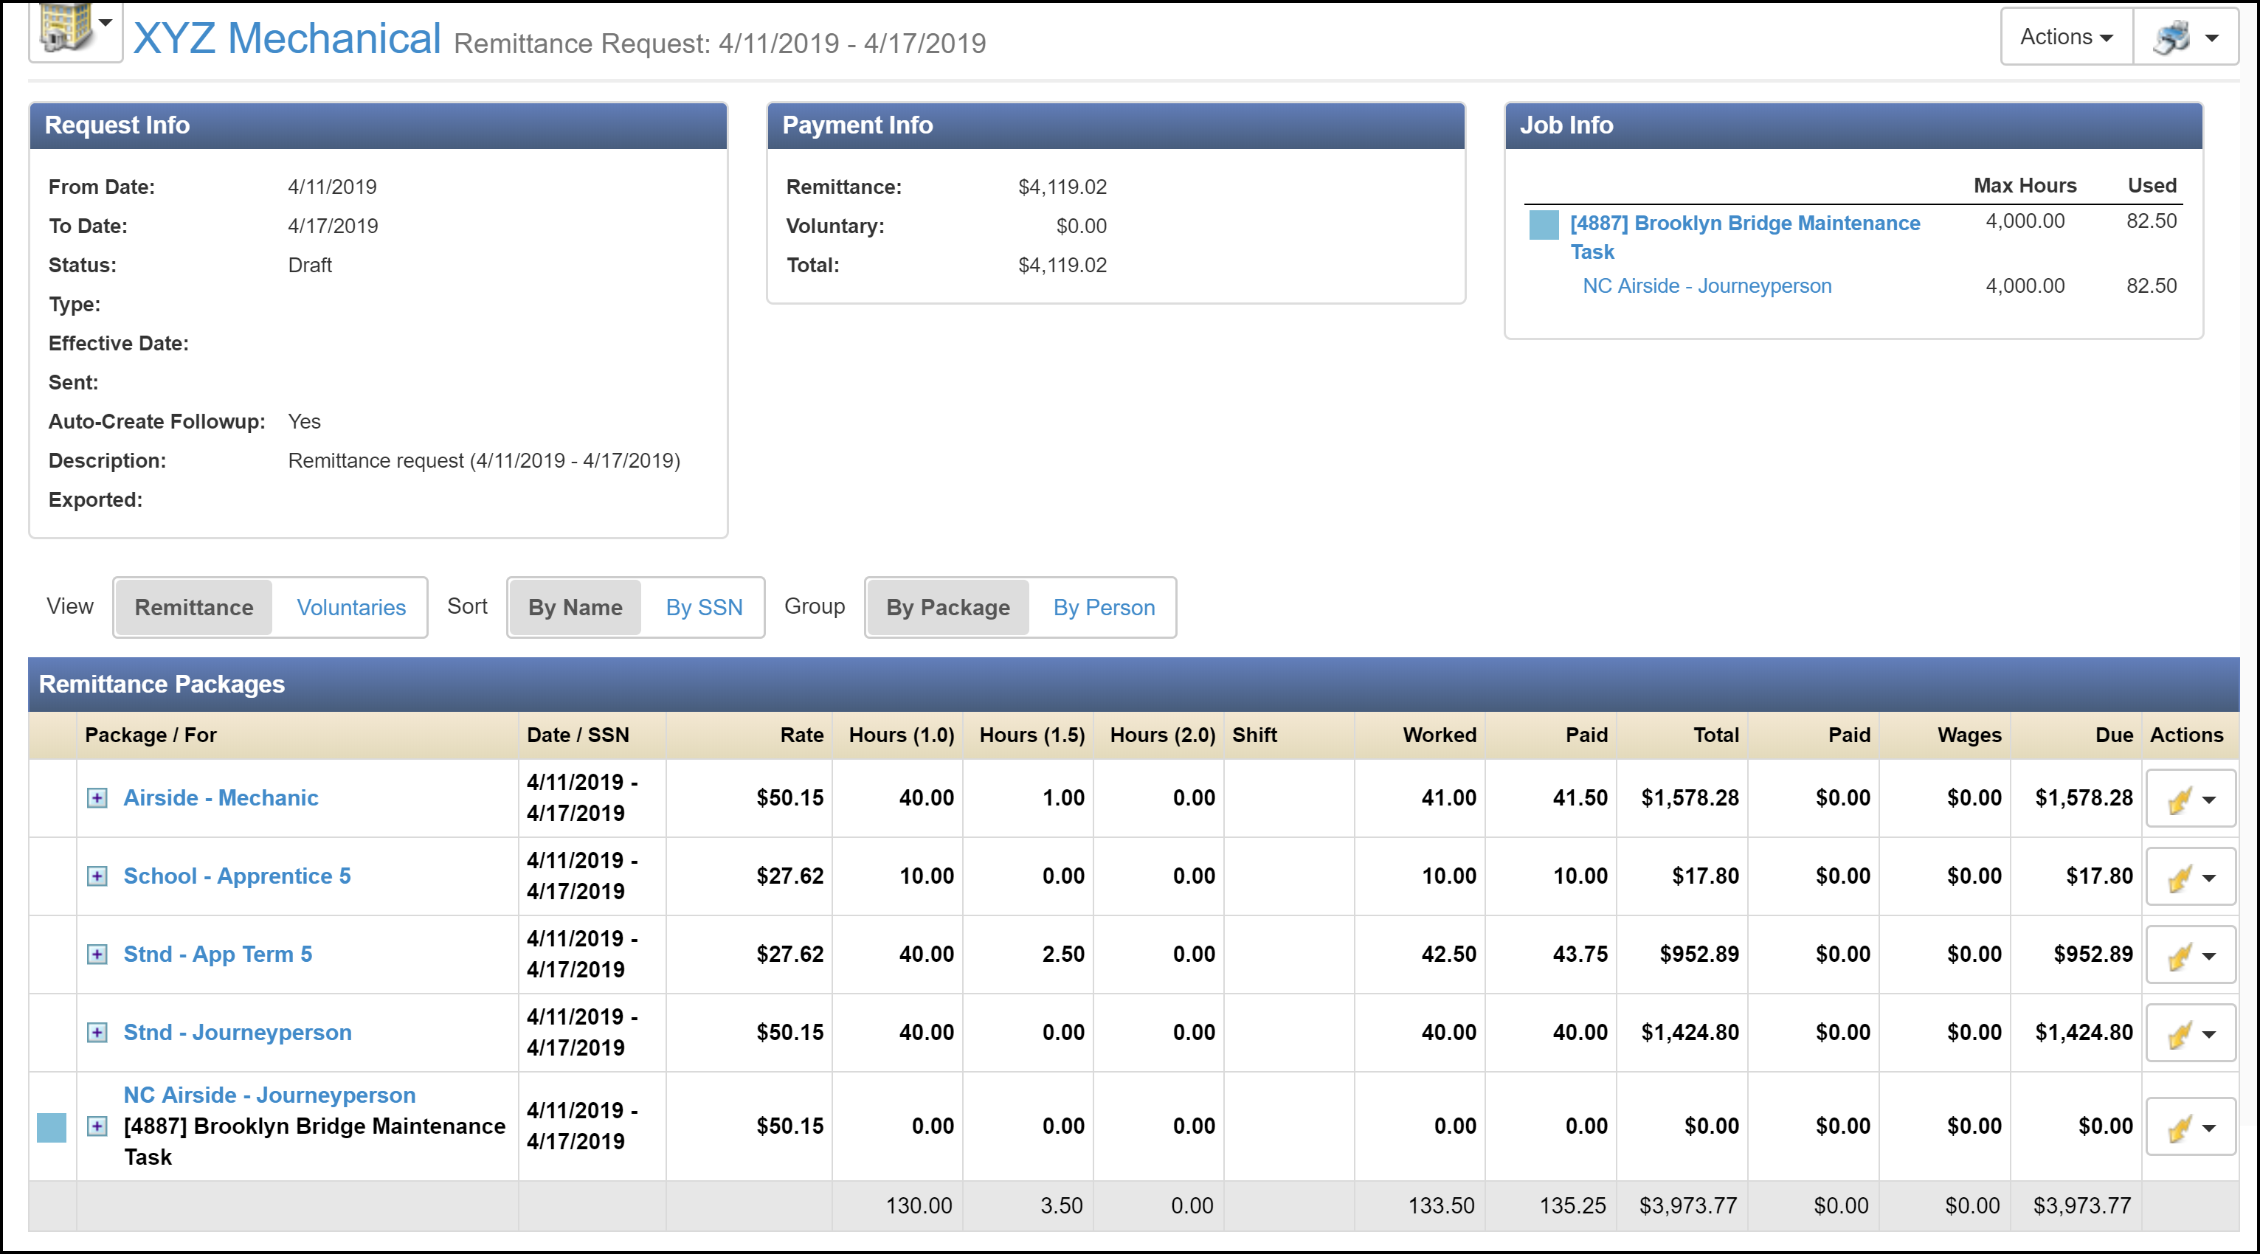

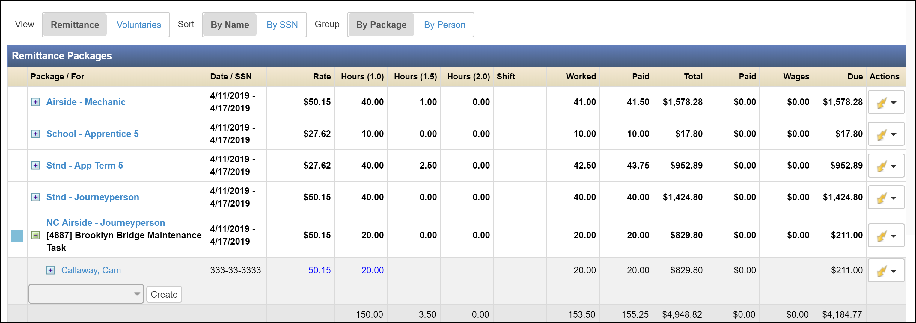

Finalizing the Remittance Package

Confirm that the total hours worked and the Total Paid/Due shown for the remittance are correct. If so, finalize the remittance package by clicking the ‘Actions’ button in the top-right and then ‘Finalize’.

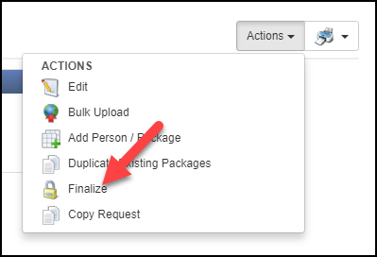

Note that the previously-blue fields that were editable are now black, indicating that they are now finalized.

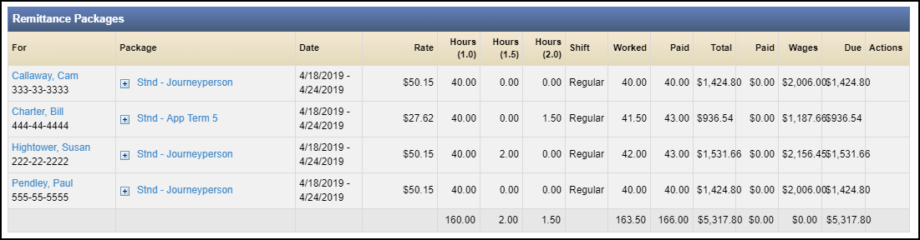

Any finalized package can be unfinalized up until the point that payment has been disbursed. Once disbursement has occurred, the remittance package is permanently locked and cannot be changed.

To unfinalized a package, click on the ‘Actions’ button and then ‘Unfinalize’ in the top-right corner.

